# Differential HPF Design (Simulated results)

Circuit:-1 (Same as Electrisense)

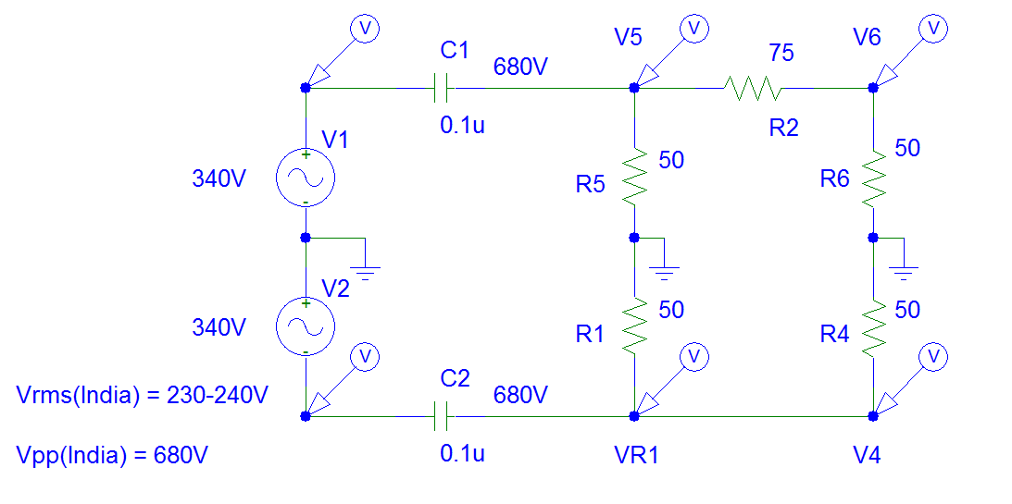

AC Response

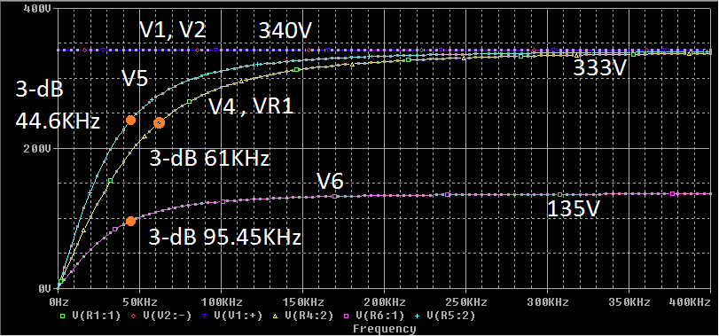

Test Circuit-2

DC Analysis to match impedance at 50 Ohms (25 Ohms on half circuit)

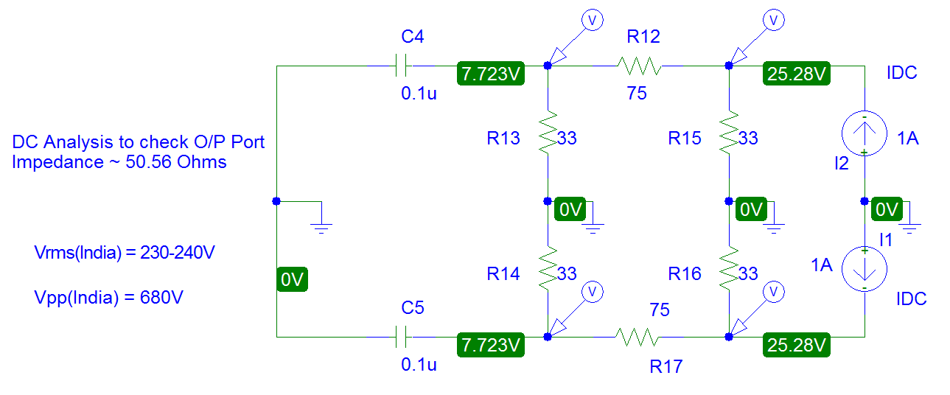

AC Analysis with Actual Input Voltage (Vpp = 680V)

